**Initial Model Training Code, Model Validation and Evaluation Report**

**Project Name :** Amazon Instrument Analysis

The dataset was split into **training (75%)** and **testing (25%)** sets.  
 Features were extracted using **TF-IDF Vectorization** (unigrams, bigrams, trigrams with 5000 features).

Two machine learning models were trained:

* **Logistic Regression**
* **Random Forest Classifier**

**Initial Model Training Code :**

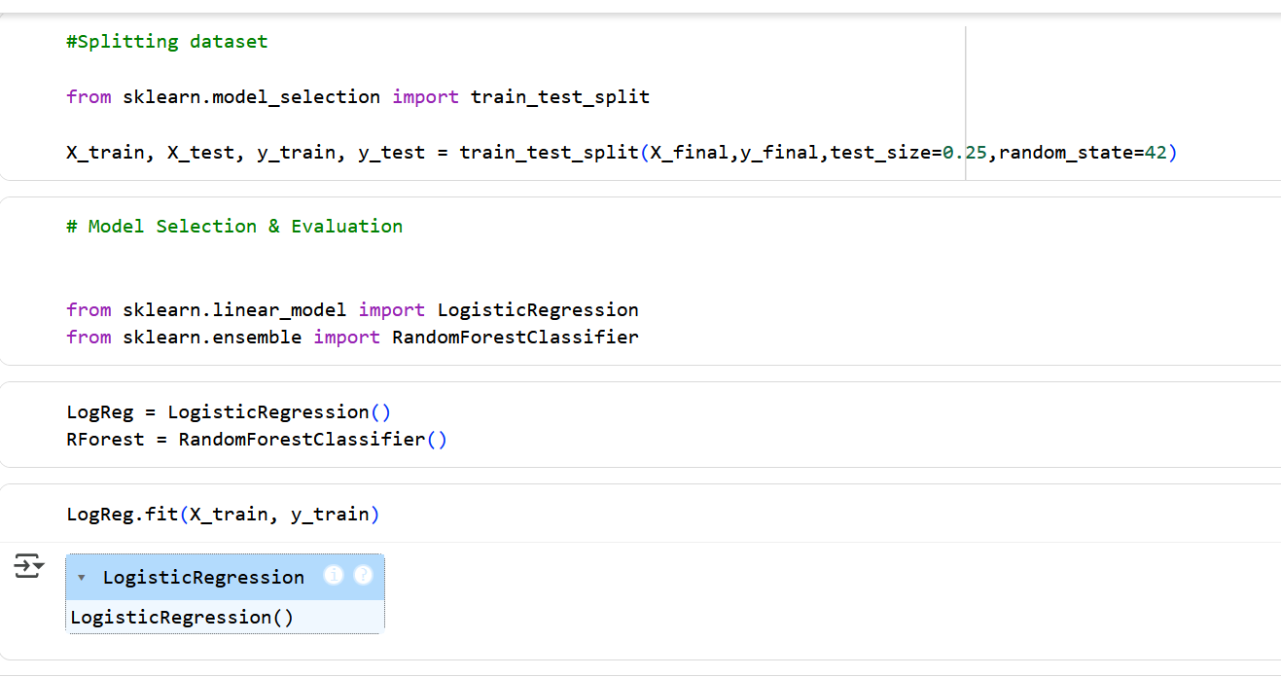

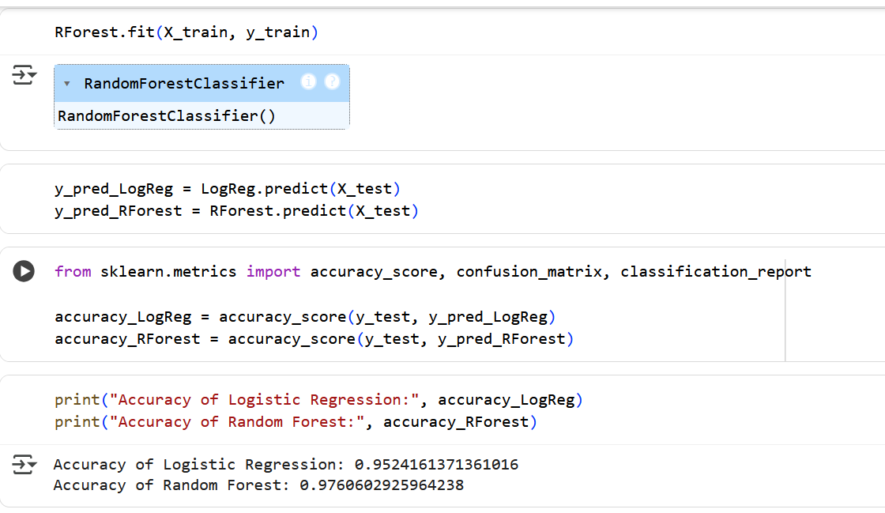

**Model Validation and Evaluation Report :**

| **MODEL** | **Summary** | **Training and Validation Performance**  **Metrics** |
| --- | --- | --- |
| Model - 1 : Logistic Regression |  |  |
| Model - 2 :Random Forest |  |  |